CLO-3: Handle programs utilizing exception and file I/O.

Due Date: 10th, December 2025 (11:59 pm)

Total Marks: 10

Instructions
Answers to all questions must be submitted in PDF Format.
Assignment document must contain a title page showing Assignment-4, your name and registration number.
Assignment document must also contain JAVA source code along with output.
The Solution of this assignment must be a single program which will be menu based.
You must follow proper JAVA naming convention for identifiers and properly document your source code.
The name of the Assignment document file should be your Registration Number. E.g. FA25BDS01.pdf
Submit your work via MS Teams which include a single JAVA file and pdf report along with output.

Plagiarism: Plagiarism is not allowed. If found plagiarized, zero marks will be awarded in the assignment.

Question - 1:
Write a program to create a file named Text_IO.txt if it does not exist. Append new data to it if it already exists. Write 100 integers created randomly into the file using text I/O. Integers are separated by a space.
Question - 2:
Write a program that will count the number of characters, words, and lines in a file. Words are separated by whitespace characters. The file name should be passed as a command-line argument.
Question - 3:
The popularity ranking of baby names from years 2015 to 2018 is downloaded from https://www.ssa.gov/oact/babynames/ and stored in files named babynameranking2015.txt, . . . ,
babynameranking2018.txt. Each file contains one thousand lines. Each line contains a ranking, a boy’s name, number for the boy’s name, a girl’s name, and number for the girl’s name. For example, the first few lines in the file babynameranking2018.txt are as follows:
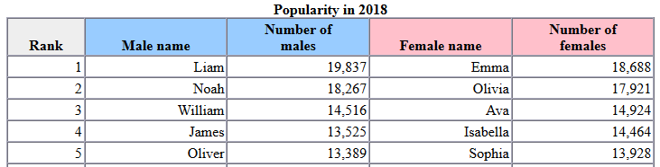 So, the boy’s name Liam and girl’s name Emma are ranked #1. Write a program that prompts the user to enter the year, gender, and followed by a name, and displays the ranking of the name for the year. Here is a sample run:
Enter the year: 2018
Enter the gender: M
Enter the name: Alexander
Alexander is ranked #11 in year 2018

Question - 4:
Write a program to read integers from a file, calculate their sum, and log any errors (e.g., non-integer values) to a separate error log file. Your program must:
- Skip invalid entries and continue processing the file.
- Log errors with specific details (e.g., line number, invalid value).
Display the total sum of valid integers.

Question - 5:
Write a program to search for a specific word in a large text file. The program must:
- Read the file line by line to avoid memory issues with large files.
- Track the line numbers where the word appears.
- Handle exceptions for missing or unreadable files.
- Output the word's occurrences and line numbers, or a message if the word is not found.

